An eight week Autumn study course

led by Dr. Peter Pattisson exploring

**Paul’s New Testament letter to the Romans**

rightly described as a book ‘that makes sense of life’.

**Methodist Church Schoolroom**, Avenue Road, Brockenhurst

Beginning **Tuesday 17th October**

**2.15pm** for one hour (please note new time)

All are welcome, whether you think you know your bible or are just beginning an exploration

Come to all sessions or come when you can

Enquiries: Dr. Peter Pattisson 01590 623457

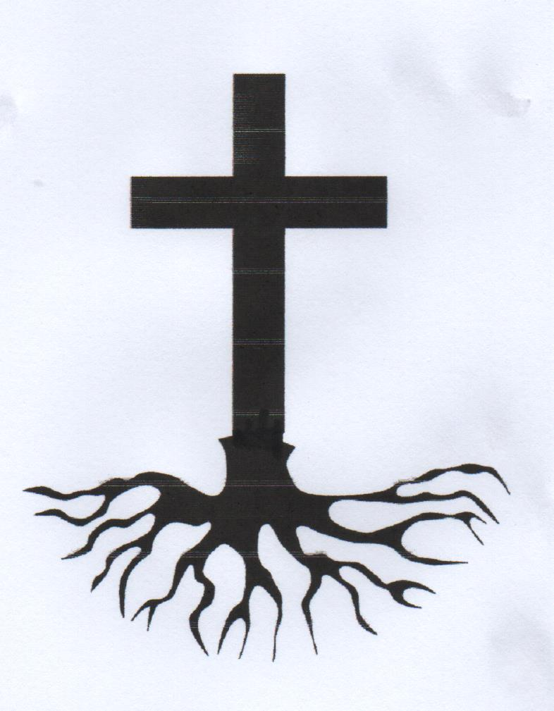

**Roots**

